**Display Property:**

* The Display property in CSS specifies an element's display behavior (the type of rendering box). The default display property value in HTML is taken from the HTML specifications or the browser/user default style sheet. **The default display value for most elements is either**[**block or inline**](https://www.scaler.com/topics/css/inline-and-block-elements-in-css)**.**
* **The Display property in CSS is used to set the display of an element**. It manages and alters how the HTML elements are shown on the web page. It is used to define how the elements behave while being exactly where they are.

**How does Display Property in CSS work?**

Each element rendered on the page has a certain display property. The value that the user assigns to the display property gets rendered.

**Syntax:**

display: value;

The default display value for most elements is either block or inline.

**Inline and Block elements** are both parts of CSS that define how the content of the web page will appear and what elements will take how much space. There are extremely important to understand as they will help in designing web pages easier and more streamlined. Both of them are values of the display property in CSS. Every HTML element has some default values applied to them. These two attributes have some properties that define the layout of elements to which they are applied.

**Inline Elements in CSS**

Inline in CSS are those elements that occupy only the space required for their content. They start in the same line where they are put without creating a new line before or after them.inline is a value of the display property in CSS.

**Example HTML tags which are inline by default:**

* <img>
* <button>
* <span>
* <b>
* <canvas>
* <em>
* <small>
* <strong>

**Note:** One more thing to note here is that inline elements in CSS don't have any effect on the height and width properties applied to them.

That's fine, but what if you want to apply the inline property manually? Well, the display property is here to the rescue. By using this property, we can set the type of any element to be inline.

**Syntax:**

.element{

display: inline;

}

To show you a comparison. Here is a <div> tag with an <img> tag without applying the inline property on <div>.

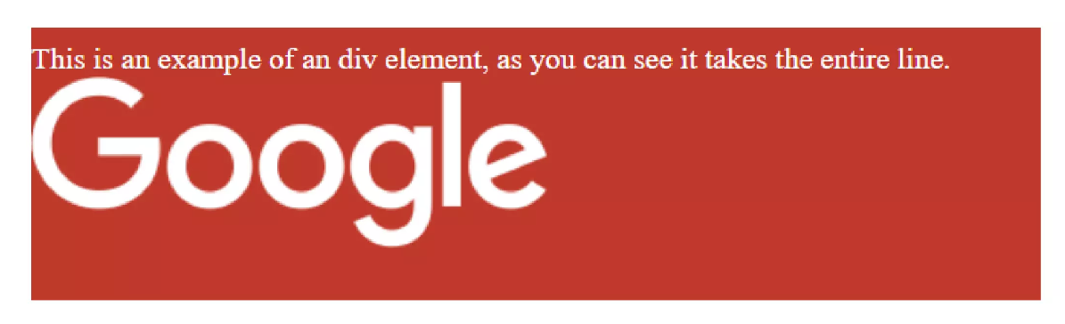

**Now, we apply the inline property as -**

.div1,{

display:inline;

}

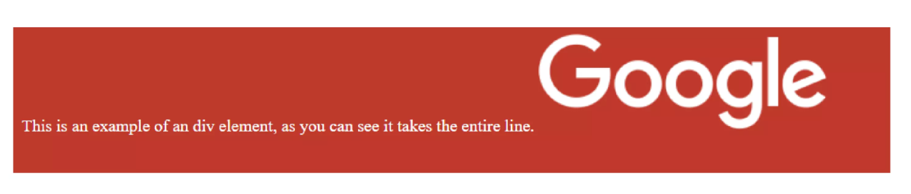

You can see how instead of the div taking the entire space, now the image and the text can both fit in a single line only.

**Block Elements in CSS:**

Unlike Inline in CSS, **Block elements** always occupy the entire width of the parent element available to them by default. block is a value of the display property in CSS.

Let's break this down. So, every block element will occupy 100% of its parents' width by default. If the parent's width is 500px it will occupy 500px if it's 1000px it will occupy 1000px. We can say those block elements create a different section and force everything after them to start from a new line.

One more way of thinking about block elements will be that they do create newline both before and after them. They always stack upon each other and never fit side to side by default, even when there is enough space to do so.

**Example HTML tags which are block by default:**

* <div>
* <p>
* <hr>
* <article>
* <form>
* <table> and many more.

To make an HTML tag a Block element manually, we again use the display property.

**Syntax:**

.element{

display:block;

}

**An example to demonstrate a block would be –**



Here there is an <img> tag and a <span> tag, both of which are inline.

Now, we apply block to it like,

img,span{

display:block;

}

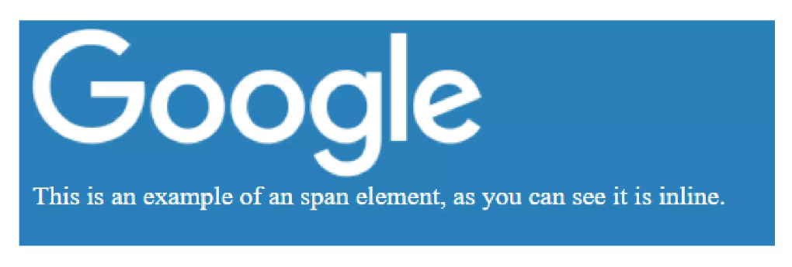

**Key Differences between Inline and Block Elements:**

|  |  |
| --- | --- |
| **Inline Elements** | **Block Elements** |
| They only take up space needed by the contents inside of them and no more. | They take up all available space, i.e. 100% of their parents |
| They don't insert newline before or after them | They do insert newline before and after them |
| Heights and width properties do not work here. | Both height and width properties can be specified for Block elements |
| They stay side by side or do not move to a newline as long as there is enough space for all the elements | They always stack on top of each other, or they automatically start from a newline even if its possible to fit the elements in a single line |
| Some common examples include <img>,<button>,<span> | Some common examples include <div>,<p>,<article> |

**None:**

It is used to turn off the display of an element. The page layout will be rendered as if the element was removed and never existed.

**Syntax-**

display: none;

**Other CSS Display Property values**

**Flex:**

It is used to display the element as a block-level flex container. The items start from the start edge of the main axis. The default [flex direction](https://www.scaler.com/topics/flex-direction-css) is row.

**Syntax:**

display: flex;